**Name -Monika Gariya**

**Email-** [**monikagariya2023@gmail.com**](mailto:monikagariya2023@gmail.com)

**Data Engineering Batch 1**

**Date – 31-01-2024**

**Topic –Set in Python, Set Methods,**

**Getting unique values from list(), reduce(),operator.countof(), pandas,numpy.unique,collection.counter(),dict.fromkeys(),**

**Python list Sort () method.**

**Introduction of JSON, Python dictionary**

**1)Set in Python**

A Set in [Python programming](https://www.geeksforgeeks.org/python-programming-language/) is an unordered collection data type that is iterable, mutable and has no duplicate elements. The major advantage of using a set, as opposed to a list, is that it has a highly optimized method for checking whether a specific element is contained in the set.

Set is represented by {} (values enclosed in curly braces)

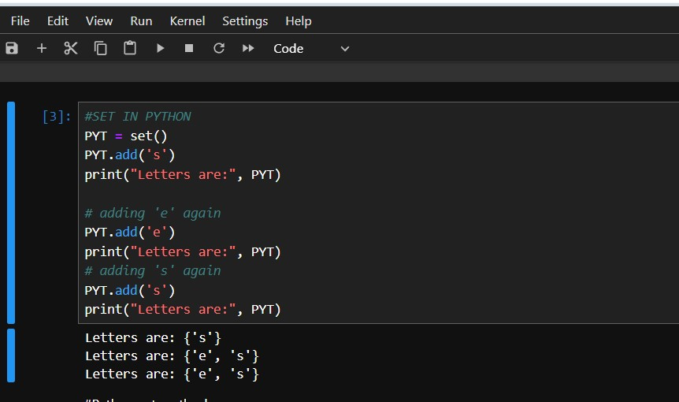

**2)Python set Methods**

We can add and remove elements form the set with the help of the below functions –

* [**add ():**](https://www.geeksforgeeks.org/set-add-python/) Adds a given element to a set
* [**clear ():**](https://www.geeksforgeeks.org/set-clear-python/) Removes all elements from the set
* **discard ():**Removes the element from the set
* [**pop ():**](https://www.geeksforgeeks.org/python-set-pop/) Returns and removes a random element from the set
* **remove ():**Removes the element from the set

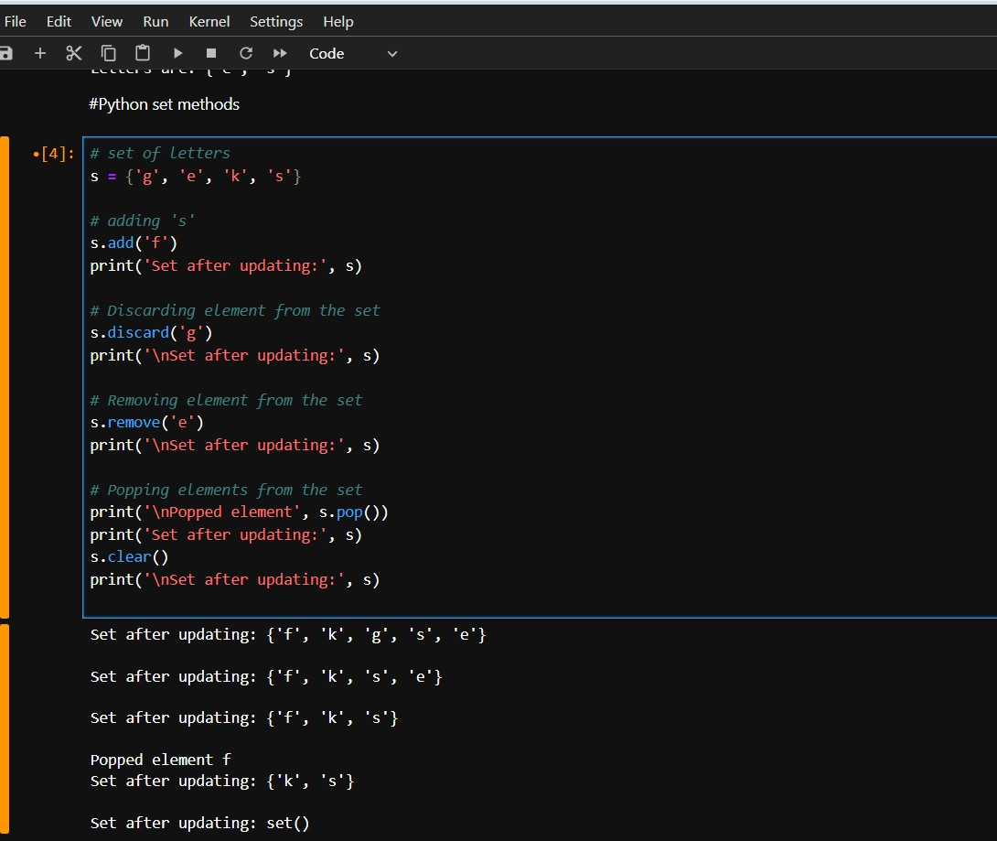

**3) Get Unique Values from a List Using Set Method**

Using set () property of Python, we can easily check for the unique values. Insert the values of the list in a set. Set only stores a value once even if it is inserted more than once. After inserting all the values in the set by list_set=set(list1), convert this set to a list to print it.

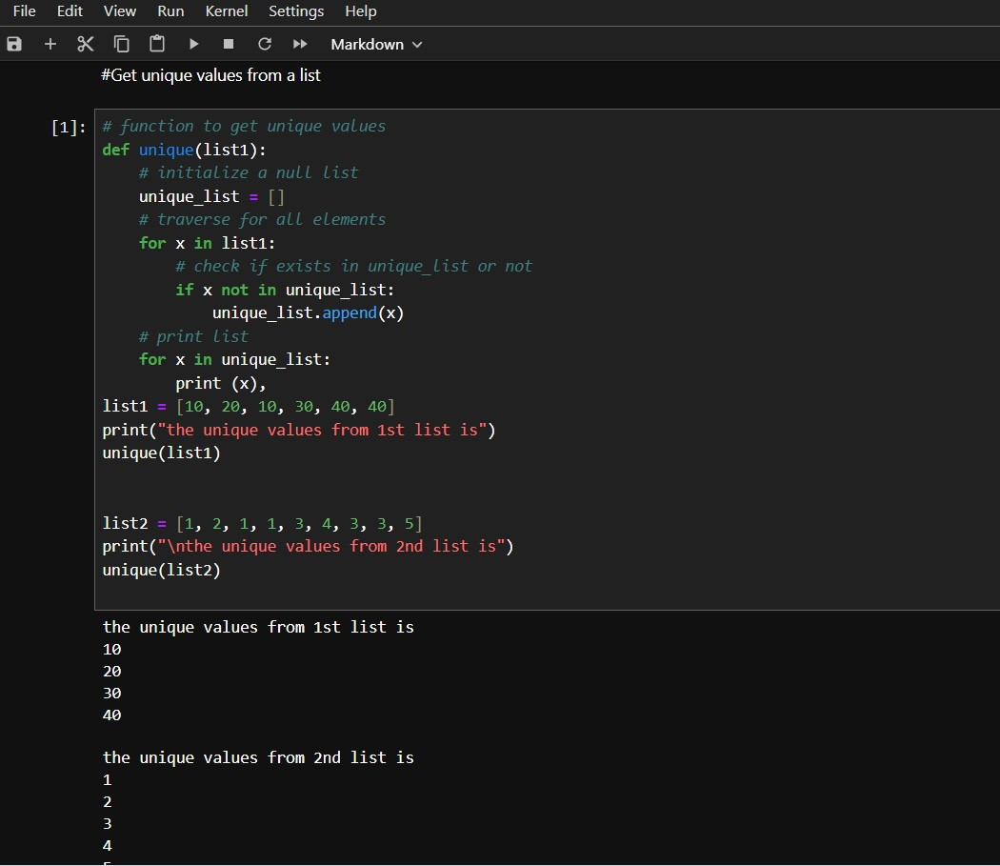

**4)Get Unique Values from a List in Python Using reduce () function**

Using Python import reduce () from functools and iterate over all element and checks if the element is a duplicate or unique value. Below is the implementation of the above approach.

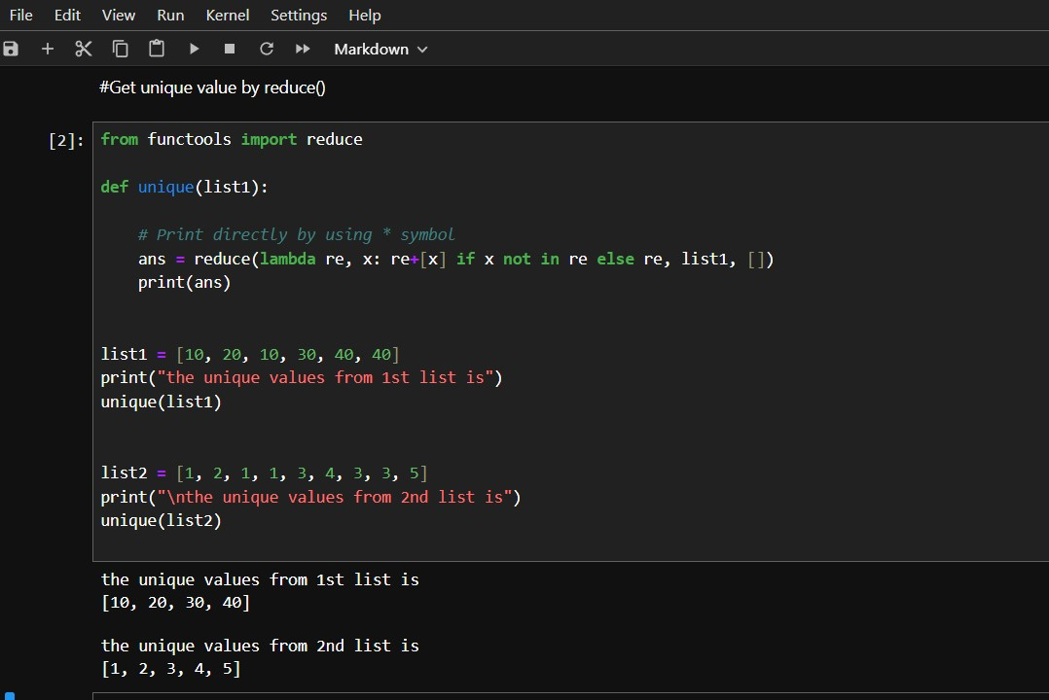

**Get Unique Values from a List in Python Using Operator.countOf() method**

The ‘unique’ function initializes an empty ‘unique_list’, then iterates through ‘list1’. For each element ‘x’, it employs ‘op.countOf()‘ to check if ‘x’ is present in ‘unique_list’. If not found (count is 0), ‘x’ is appended to ‘unique_list’. The final unique values are printed using a loop.

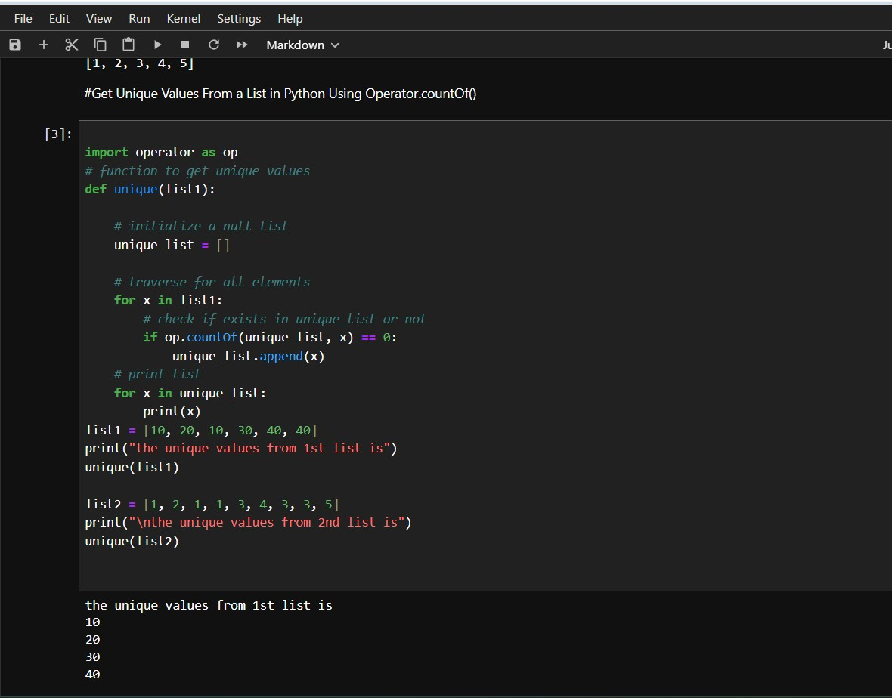

**Get Unique Values from a List in Python Using pandas module**

The ‘unique’ function utilizes Pandas to create a Series from ‘list1’, then employs ‘drop_duplicates ()’ to eliminate duplicates and obtain a list of unique values. Subsequently, it iterates through the unique list and prints each element.

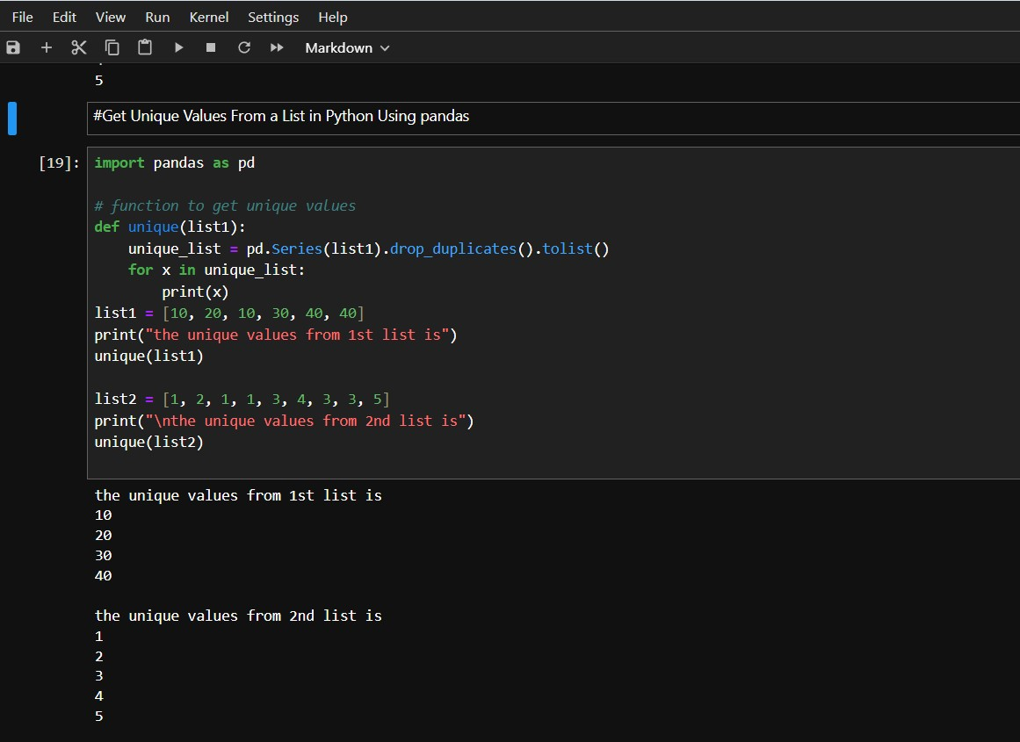

**Get Unique Values from a List Using numpy.unique**

Using Python’s import numpy, the unique elements in the array are also obtained. In the first step convert the list to **x=numpy.array(list)** and then use **numpy.unique(x)** function to get the unique values from the list. **numpy.unique ()** returns only the unique values in the list.

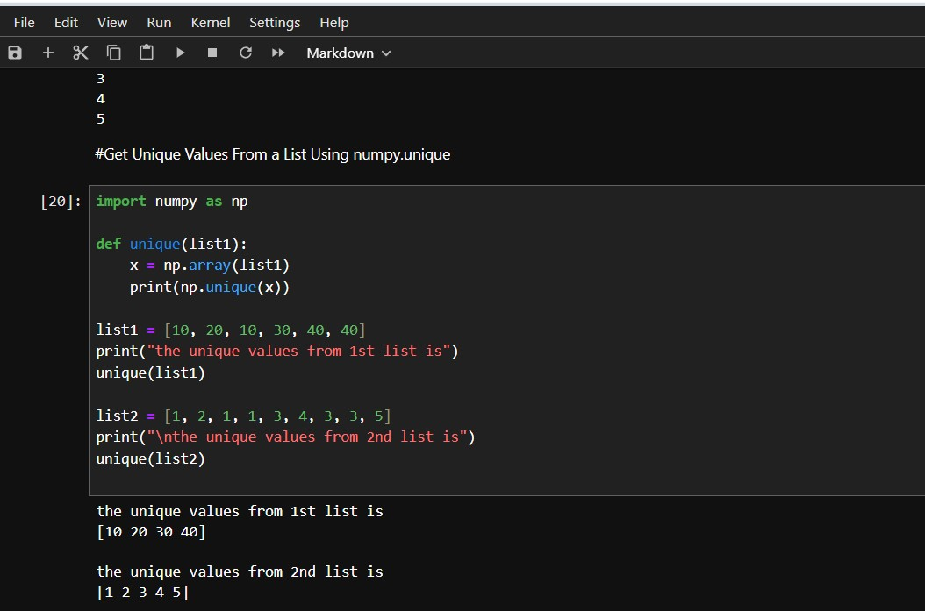

**Get Unique Values from a List in Python Using collections.Counter ()**

Using Python to import Counter () from collections print all the keys of Counter elements or we print directly by using the **“*”**symbol.

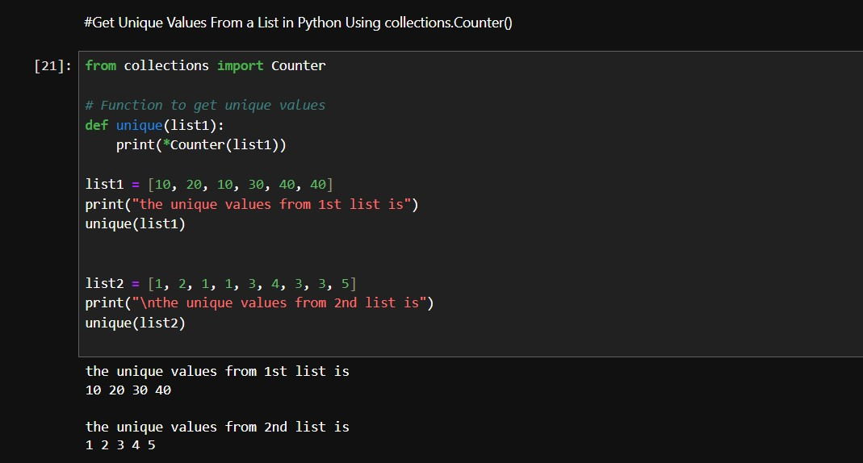

**Get Unique Values From a List Using dict.fromkeys()**

Using the from keys() method of dictionary data structure we can fetch the unique elements. Firstly we need to define a list that consists of duplicate elements. Then we need to use a variable in which we will store the result after using the from keys() method

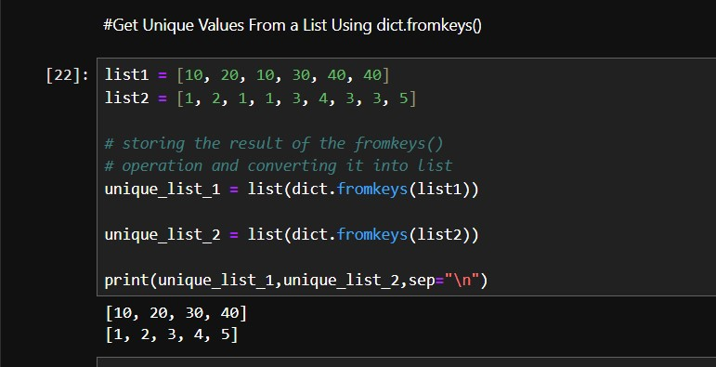

**5)Python List sort () Method**

**Python list sort()**method sorts the elements of a list. It sorts in ascending order by default but can also sort values in descending order or ina custom manner using its parameters.

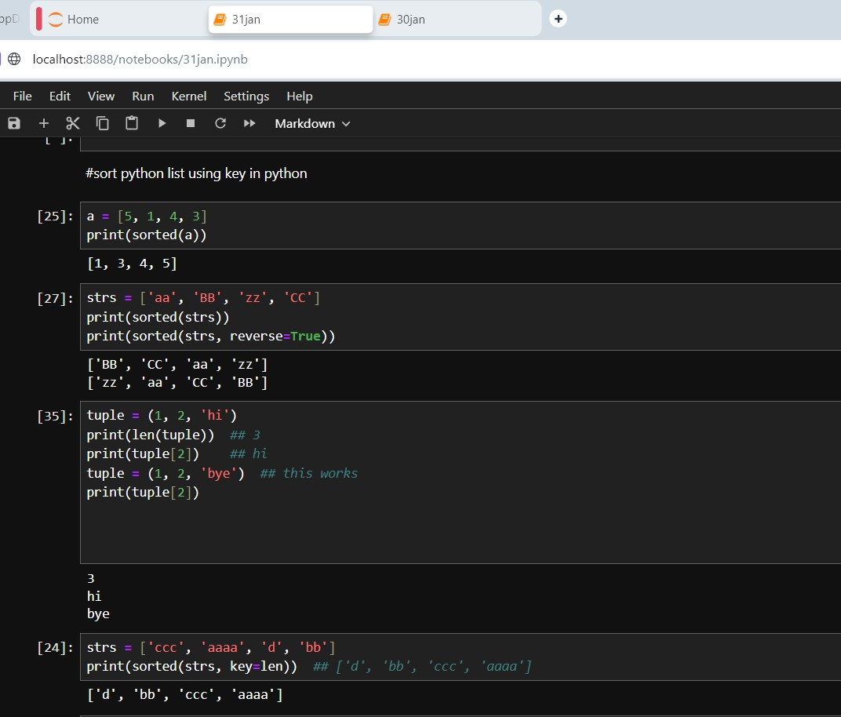

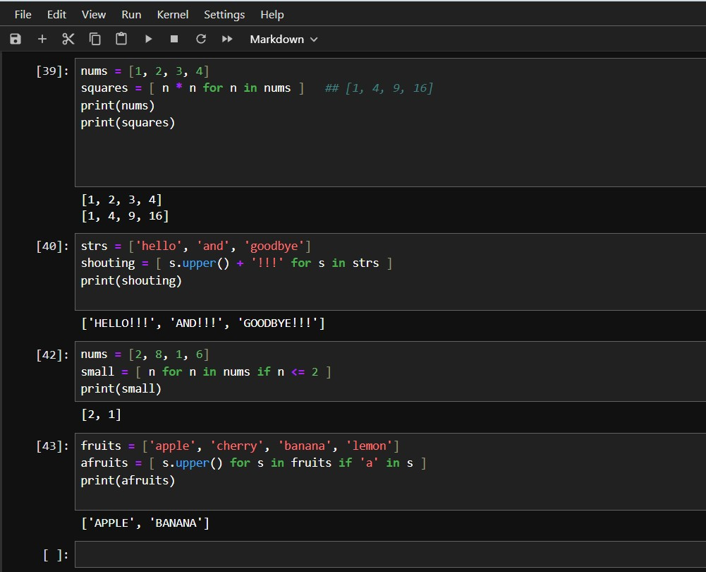

**6)JSON Introduction**

**JSON** stands for **J**ava**S**cript **O**bject **N**otation. It is a format for structuring data. This format is used by different web applications to communicate with each other. JSON is a lightweight format for storing and transporting data JSON is often used when data is sent from a server to a web page.

**Features of JSON:**

**1)Easy to understand:** JSON is easy to read and write.

**2)Format:** It is a text-based interchange format. It can store any kind of data in an array of video, audio, and image anything that you required.

**3)Support:** It is light-weighted and supported by almost every language and OS. It has a wide range of support for the browsers approx. each browser supported by JSON.

**4)Dependency:** It is an independent language that is text-based. It is much faster compared to other text-based structured data.

**Advantages of JSON:**

* JSON stores all the data in an array so data transfer makes easier. That’s why JSON is the best for sharing data of any size even audio, video, etc.
* Its syntax is very easy to use. Its syntax is very small and light-weighted that’s the reason that it executes and response in a faster way.
* JSON has a wide range for the browser support compatibility with the operating systems, it doesn’t require much effort to make it all browser compatible.
* On the server-side parsing the most important part that developers want, if the parsing will be fast on the server side then the user can get the fast response, so in this case JSON server-side parsing is the strong point compare tot others.

**Disadvantages of JSON:**

* The main disadvantage for JSON is that there is no error handling in JSON, if there was a slight mistake in the JSON script then you will not get the structured data.
* JSON becomes quite dangerous when you used it with some unauthorized browsers. Like JSON service return a JSON file wrapped in a function call that has to be executed by the browsers if the browsers are unauthorized then your data can be hacked.
* JSON has limited supported tools that we can use during JSON development.

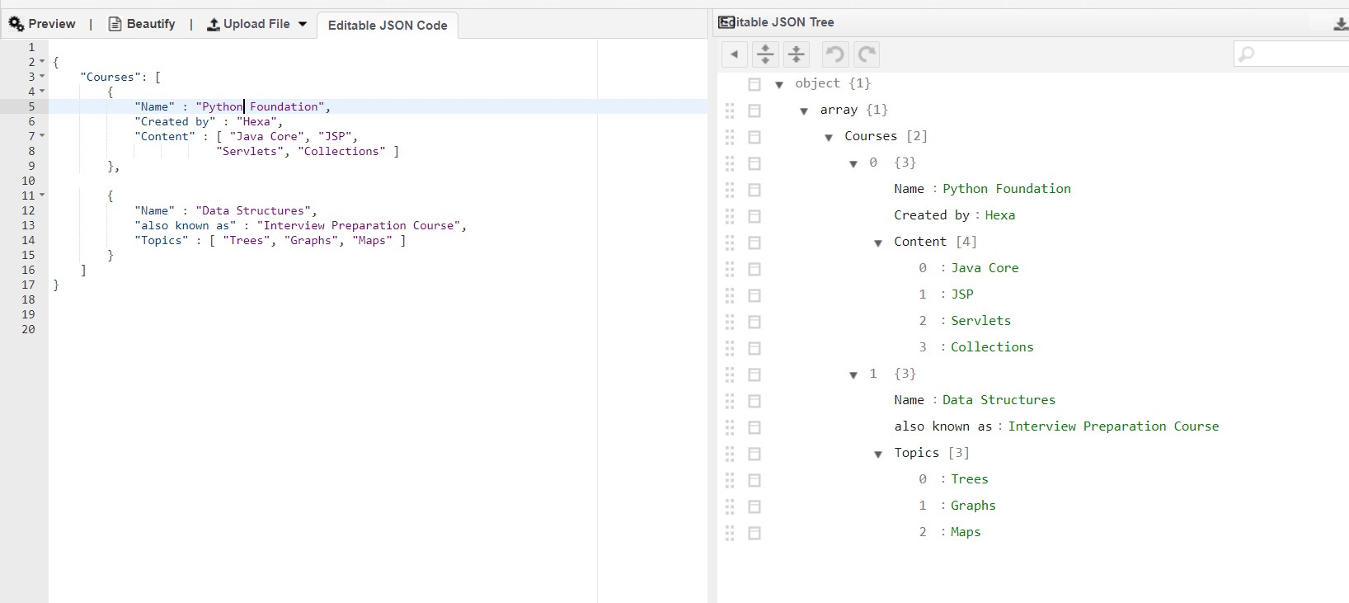

1)JSON String To Dictionary python

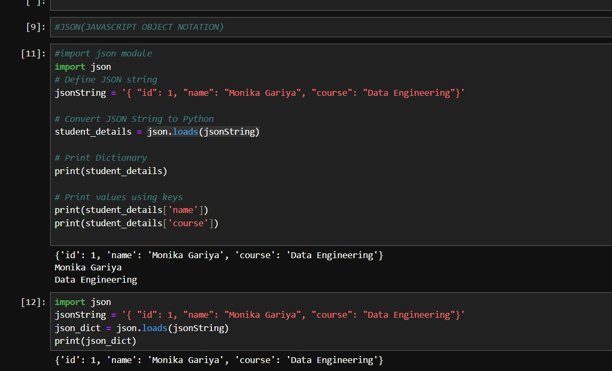

2)Convert JSON String to Dictionary in python

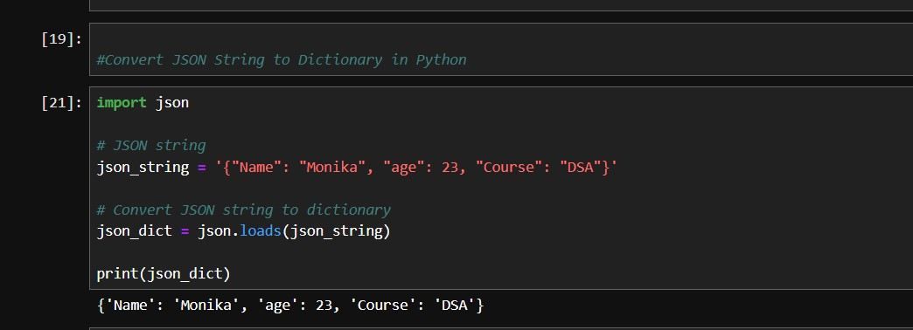

3)Python parse JSON String

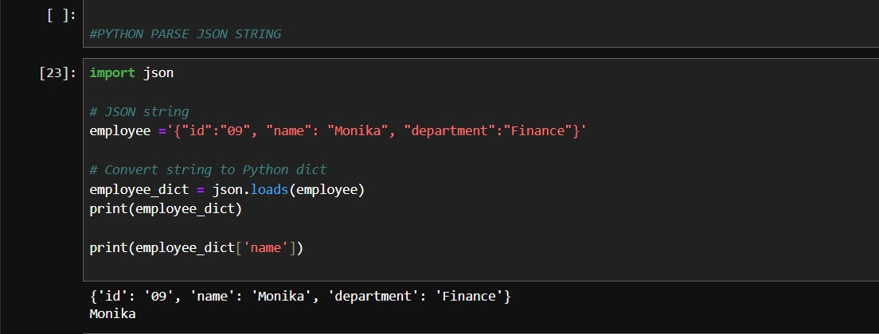

4) Convert python dictionary to JSON

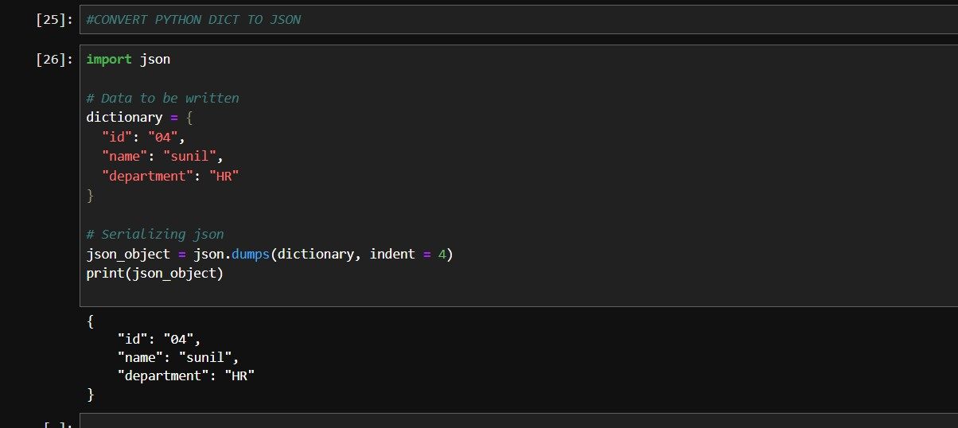

5)Python Pretty Print JSON-When we convert a string to JSON the data is in a less readable format. To make it more readable we can use pretty printing by passing additional arguments in json.dumps() function

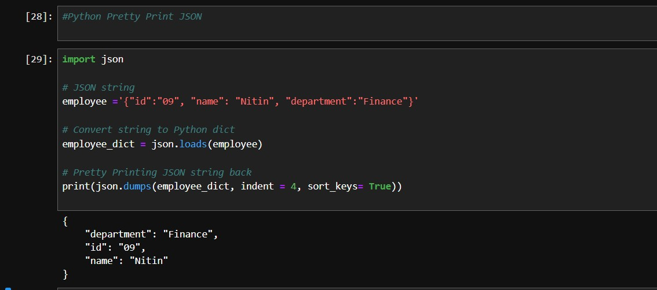

6)Python read JSON File

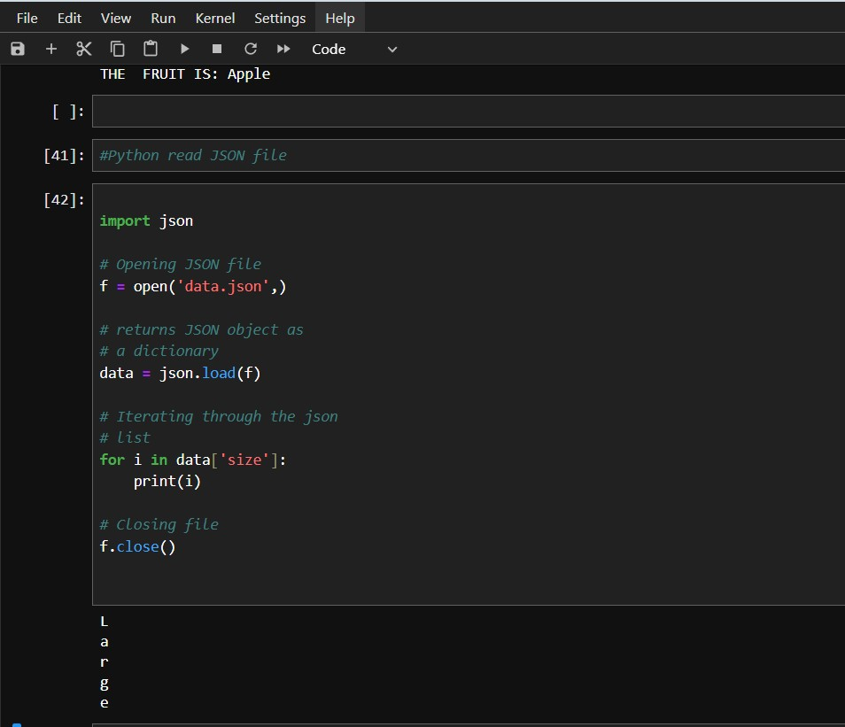

7)Convert JSON File to Python Object

